
Secure Music Copyright Application: Design Document

Development Team Project_1
Date: 3th November

1.0 Executive Summary
This design document presents a comprehensive design for a Secure Music Copyright Application addressing industry concerns regarding copyright infringement. The system implements a secure digital enclave for musical artefacts employing cryptographic integrity verification, AES-256 encryption, and blockchain-based timestamping to ensure copyright protection and non-repudiation (Saltzer & Schroeder, 1975).

2.0 System Architecture Overview
The application provides a multi-layered security architecture for storing lyrics, musical scores, and audio recordings (MP3, FLAC, WAV). Core security features include:
- Cryptographic checksum generation using SHA-256
- Military-grade encryption (AES-256) for data at rest
- Immutable timestamping via blockchain integration
- Role-based access control with principle of least privilege

3.0 UML Design Specification
3.1 Use Case Diagram Copyright Management System
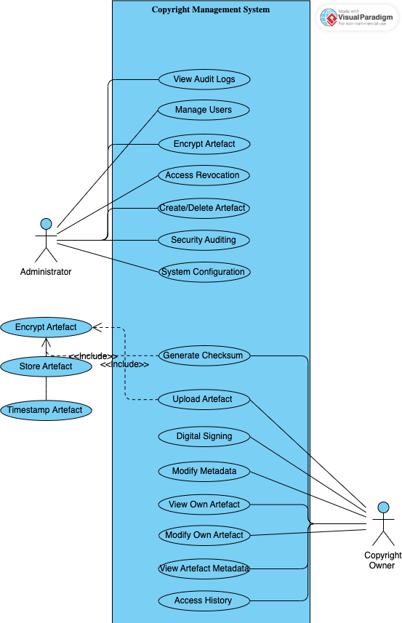

Security Analysis: This use case Figure model implements mandatory access control where users can only modify their own artefacts while maintaining view-only access to others' content, preventing unauthorized modifications (Saltzer,1975).

3.2 Comprehensive Class Diagram with Design Patterns
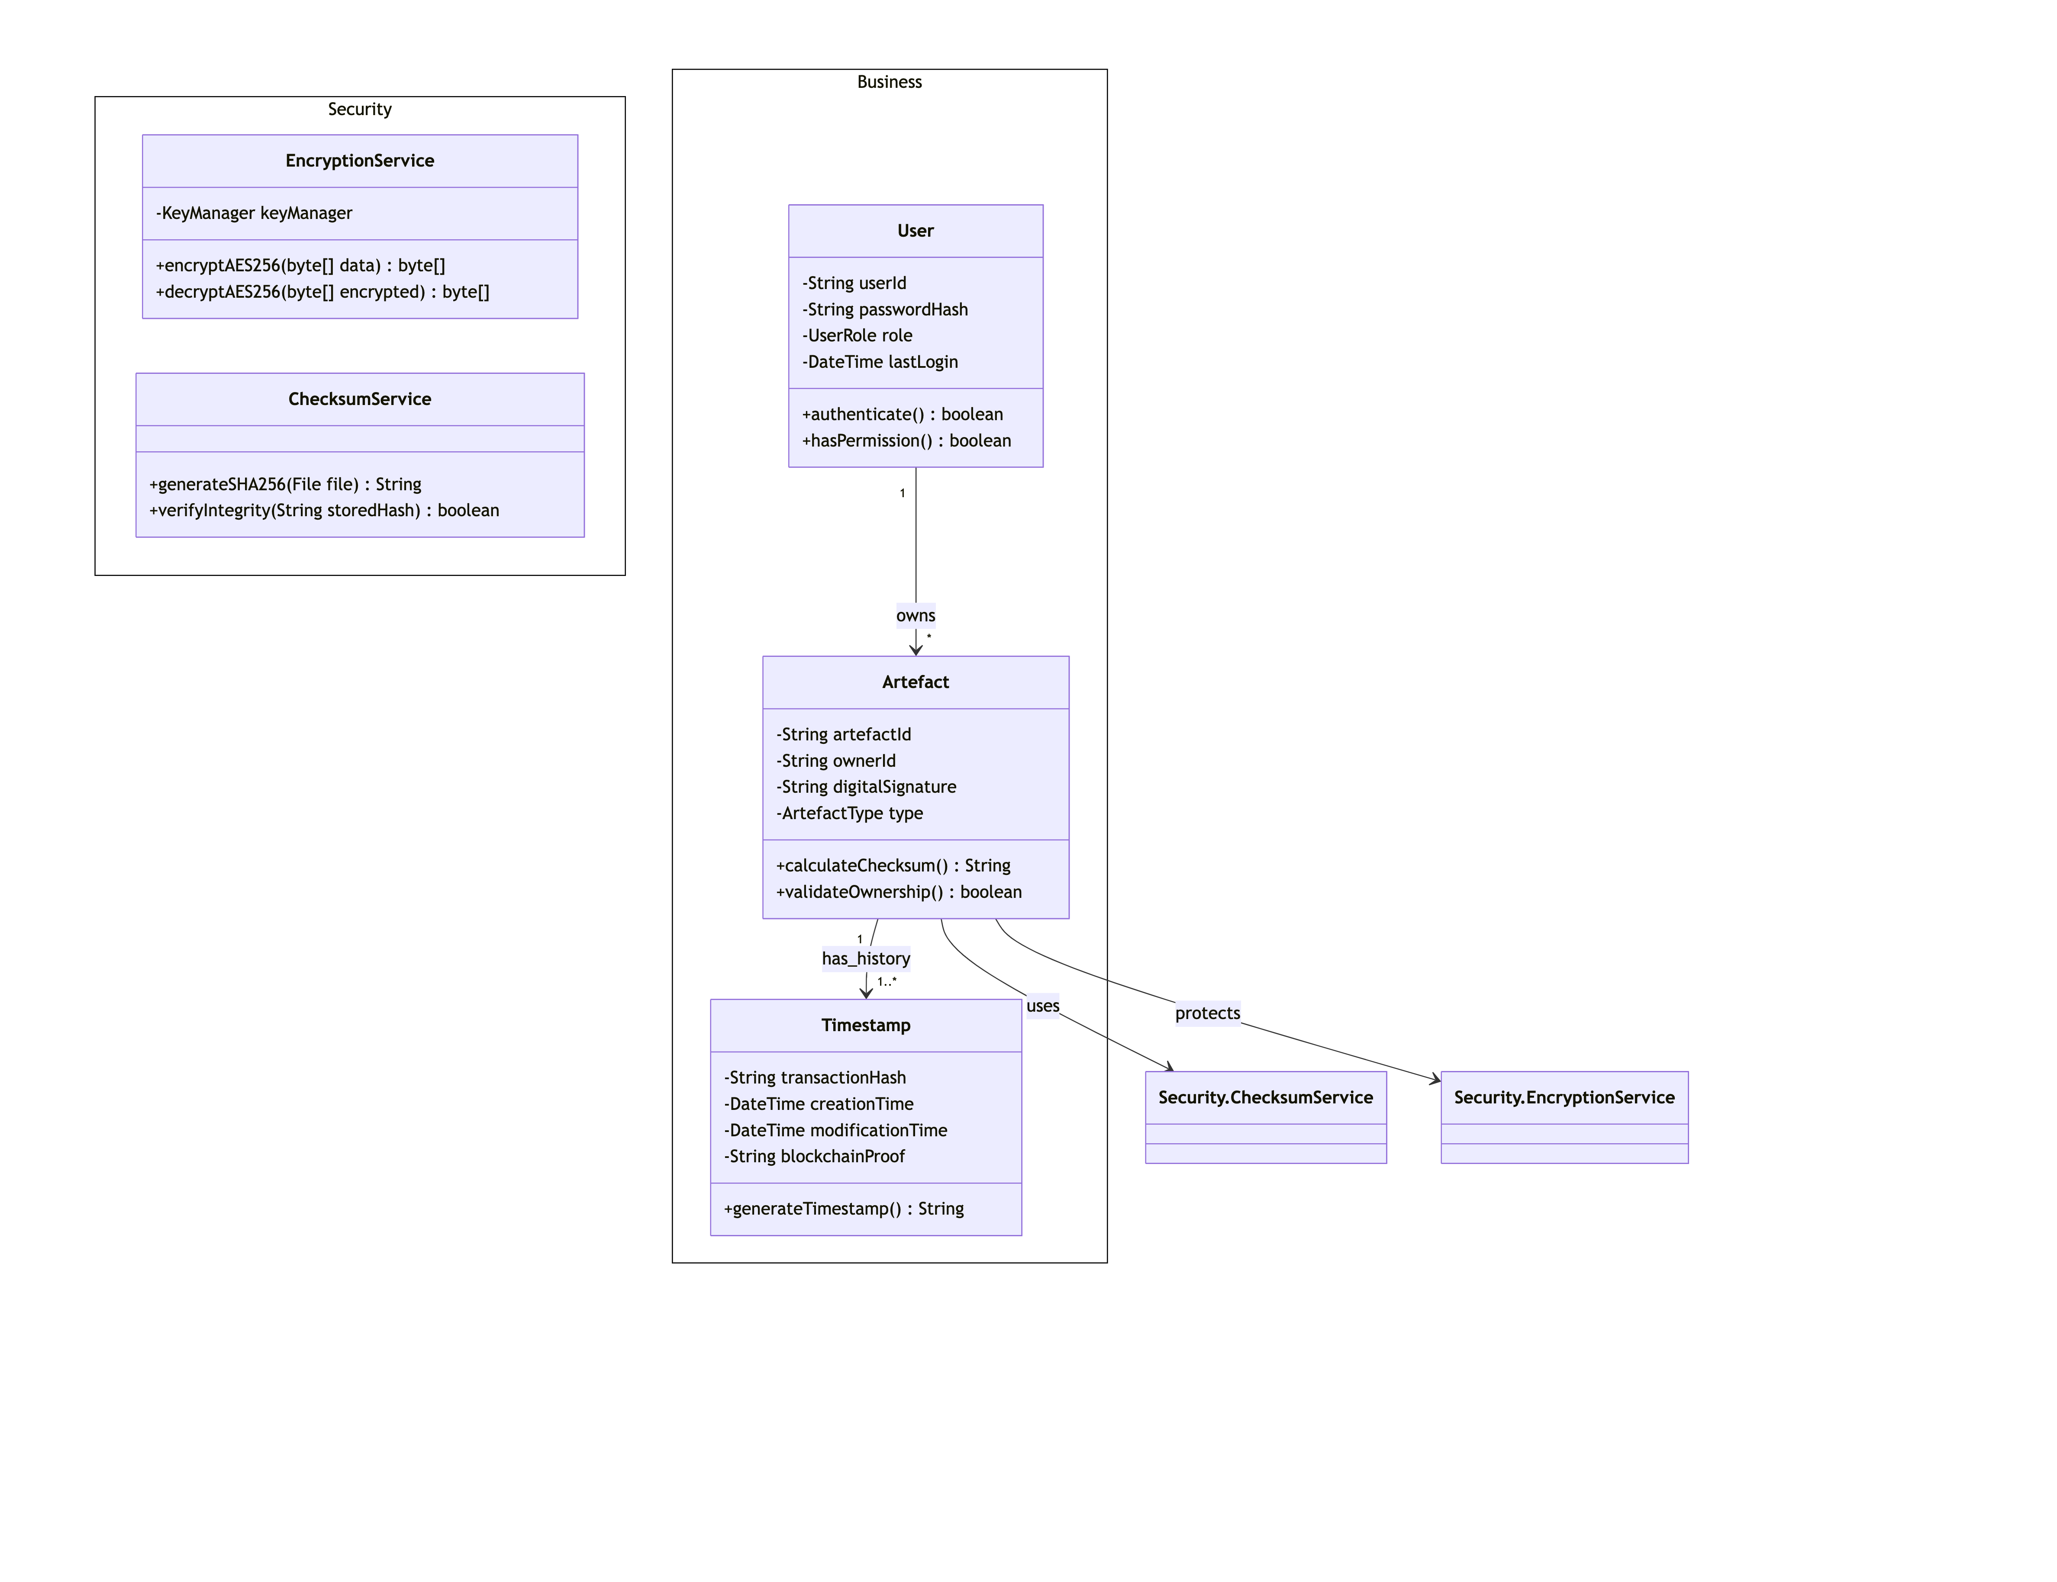
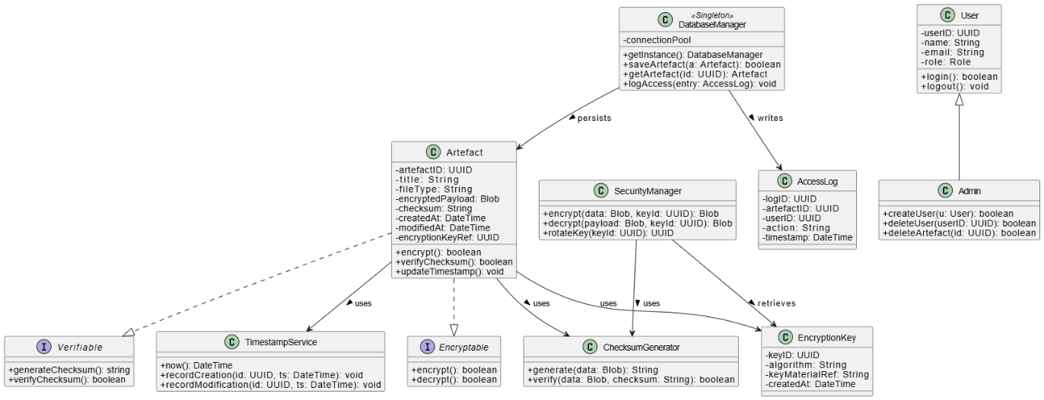

This class diagram Figurs logically structures the system using fundamental classes like User and Artefact, illustrating their attributes, methods, and relationships. Encapsulation, inheritance, and abstraction improve maintainability and security through modularity and code reuse.

Object-Oriented Principles Demonstrated:
- Encapsulation: All attributes private with controlled accessors
- Inheritance: User hierarchy with Admin/Owner/Viewer specializations
- Abstraction: Simplified interfaces for complex cryptographic operations
- Polymorphism: Artefact types handled through common interface

3.3 Secure Sequence Diagram: Artefact Upload Workflow
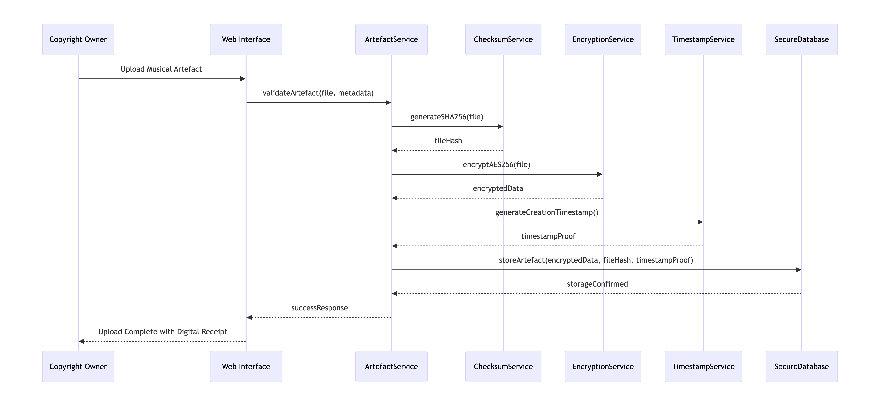

Security Protocol: This sequence Figure ensures cryptographic protection before persistence, preventing exposure of unencrypted data and maintaining integrity throughout the workflow.
The important operations include artefact uploading, encryption, checksum processing, viewing, modification, as well as user account management (Aniche, 2024).
4.0 Design Patterns & Security Paradigms
The design may resort to the existing OOP to improve efficiency and maintainability. DatabaseManager is implemented in accordance with a singleton pattern to prevent the occurrence of data conflicts. Objects of encryption and checksum are constructed through a factory allowing a future update in algorithms (Ahmed, 2025).
The Observer pattern will automatically update artefact timestamps when they are being changed. Security follows major principles, which are; smallest privileges, encryption at rest, and regular computing of checksums as an anti-tampering measure.

5.1 Architectural Patterns & Design Patterns with Critical Analysis
Phase | Pattern | Implementation | Justification | Source
1 | Singleton | DatabaseManager.getInstance() | Prevents multiple instances, ensures connection pool consistency | Gamma et al. (1994)
2 | Factory Method | EncryptionFactory.createAlgorithm() | - Enables easy algorithm updates without code modification  - Artefact creation based on type (lyrics/score/audio) | Ahmed (2025)
3 | Strategy | EncryptionStrategy interface | - Supports interchangeable cryptographic implementations  - Interchangeable encryption algorithms | Martin (2000)
4 | Observer | SecurityEventNotifier → AuditLogger | Provides real-time monitoring without tight coupling | Gamma et al. (1994)

- Critical Documentation:
The Singleton pattern centralizes database access, preventing resource conflicts. consistency (Gamma et al., 1994).
Factory Method allows seamless algorithm upgrades, supporting future cryptographic requirements (Ahmed, 2025).
Strategy pattern enables cryptographic agility, essential for maintaining security standards (Martin, 2000).
Observer pattern ensures comprehensive audit trails for compliance monitoring.

5.2 Security Implementation
- Confidentiality: AES-256-GCM encryption with key rotation
- Integrity: SHA-256 checksums with periodic verification (Izurieta, 2025)
- Availability: Database indexing on frequently accessed fields
- Non-Repudiation: Blockchain-anchored timestamps
- Authentication: Multi-factor authentication readiness

5.3 Object-Oriented Excellence
The design demonstrates sophisticated OOP through:
- Composition over Inheritance: Security services composed into artefacts
- Interface Segregation: Separate interfaces for different user roles
- Dependency Inversion: High-level modules independent of low-level implementations

6.0 Compliance & Standards Alignment
UML Standards Compliance:
- Adheres to UML 2.5.1 specification (OMG, 2017)
- Proper stereotyping and annotation usage
- Consistent naming conventions and visibility notations

Security Standards:
- NIST SP 800-175B for cryptographic key management (NIST, 2020)
- OWASP Application Security Verification Standard
- GDPR compliance through data encryption and access controls

References
- Ahmed, S., 2025. Enhancing Software Development Efficiency: The Role of Design Patterns in Code Reusability and Flexibility. International Journal of Engineering, Business and Management, 9(1), p.601734. https://www.academia.edu/download/122063613/7IJEBM_MAR20253_Enhancing.pdf
- Aniche, M., 2024. Simple Object-oriented Design: Create Clean, Maintainable Applications. Simon and Schuster. https://books.google.com/books?hl=en&lr=&id=8mcFEQAAQBAJ&oi=fnd&pg=PR12&dq=Design+Patterns:+Elements+of+Reusable+Object-Oriented+Software.&ots=5mN7EcLIM-&sig=BayrgturJH2RrTseYeTLhPf4xRk
- Izurieta, C., 2025. Design Patterns and Reusability. In Realizing Complex Integrated Systems (pp. 139-156). CRC Press. https://www.taylorfrancis.com/chapters/edit/10.1201/9781003188377-14/design-patterns-reusability-clemente-izurieta
- Gamma, E. et al. (1994) Design Patterns: Elements of Reusable Object-Oriented Software. Addison-Wesley Professional.
- Martin, R.C. (2000) Design Principles and Design Patterns. [online] Available at: http://www.butunclebob.com/ArticleS.UncleBob.PrinciplesOfOod (Accessed: 27 October 2025).
- National Institute of Standards and Technology (2020) *SHA-3 Standard: Permutation-Based Hash and Extendable-Output Functions*. FIPS PUB 202.
- Object Management Group (2017) Unified Modeling Language Specification Version 2.5.1. [online] Available at: https://www.omg.org/spec/UML/2.5.1/ (Accessed: 27 October 2025).
- Saltzer, J.H. and Schroeder, M.D. (1975) 'The protection of information in computer systems', Proceedings of the IEEE, 63(9), pp. 1278-1308.

